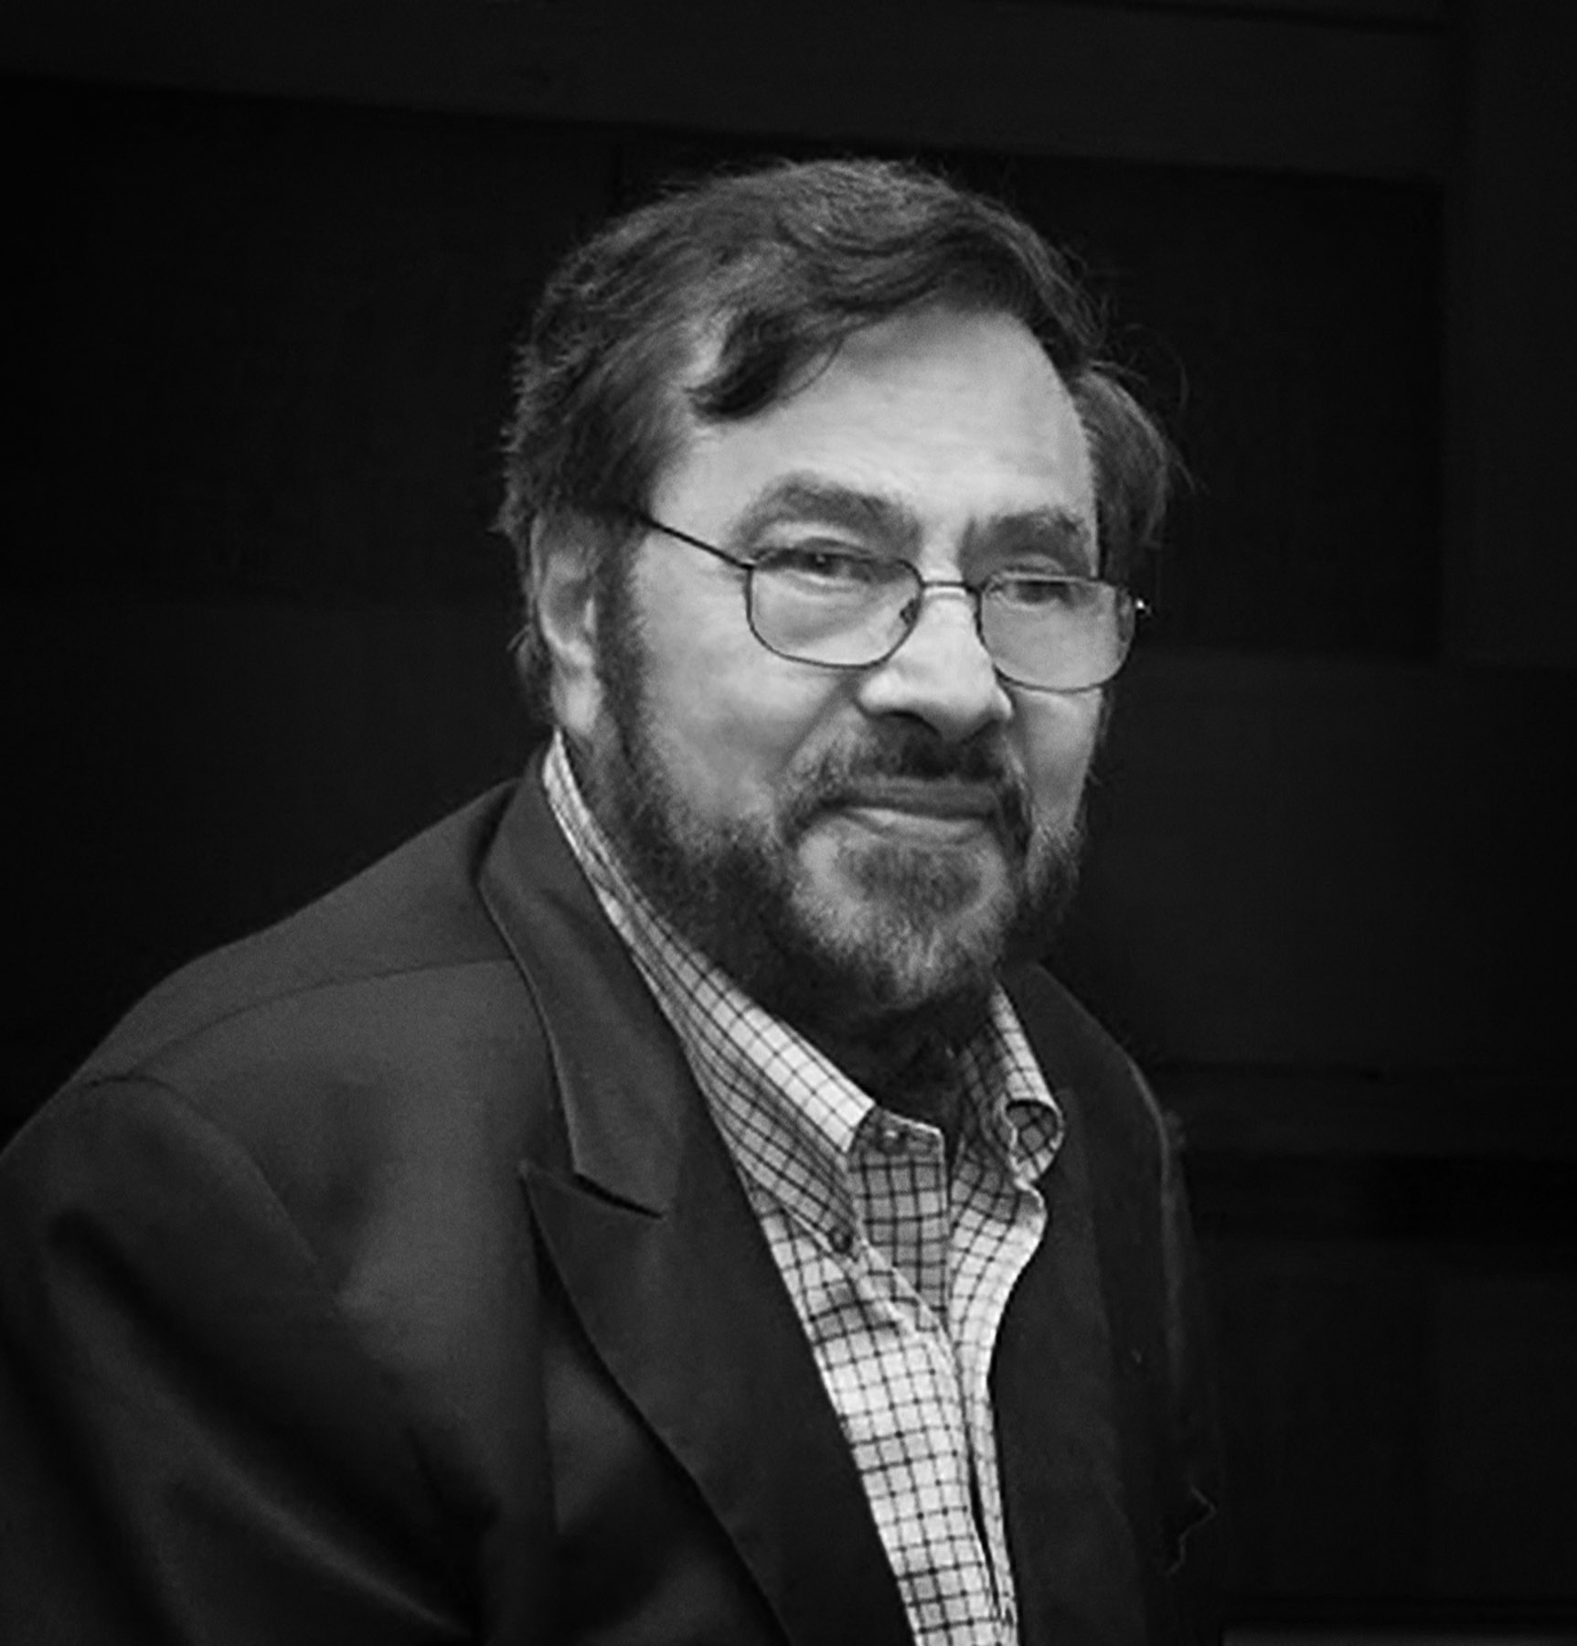
William Barletta is Adjunct Professor of Physics at MIT and Director Emeritus of the Accelerator Division and Homeland Security Program at Lawrence Berkeley National Laboratory. Internationally, he is a member of the Scientific Council of the Centro Fermi and Museum in Rome, the Advisory Board of the John Adams Institute in the UK, senior advisor to the President of Sincrotrone Trieste, Adjunct Professor in the Faculty of Economics of the University of Ljubljana and Coordinating Editor-in-Chief of Nuclear Instruments and Methods-A and of Physics Open.
He has edited four books about accelerator science and co-authored four books concerning cybersecurity and international cyber-law. His textbook, Strategic Management of Research Organizations, is printing by the CRC Press of Taylor and Francis Group. He holds four patents and has published more than 180 scientific papers plus 30 reports on strategic technologies.
He holds a Ph.D. (Physics) from the University of Chicago and is a fellow of the APS and a Foreign Member of the Academy of Sciences of the Bologna Institute in Italy.

